**CANDIDATES NAME:…………………………………………………………………**

|  |  |  |  |  |  |  |  |
| --- | --- | --- | --- | --- | --- | --- | --- |
| **INDEX NUMBER** | | | | | | | |
|  |  |  |  |  |  |  |  |

**SIGNATURE: ……………………………………**

**535/1**

**PHYSICS**

**PAPER 1**

**JUNE/JULY**

**2 HOURS 15 MINUTES**

**MOCK EXAMINATIONS SET 1 2019**

**Uganda Certificate of Education**

**PHYSICS**

**PAPER 1**

2 HOURS 15 MINUTES

**INSTRUCTIONS TO CANDIDATE:**

* *Section A contains 40 objective type questions. You are required to write the correct answer A, B, C or D against each question in the box on the right hand side.*
* *Section B contains 10 structured questions. Answers are to be written in the spaces provided on the question paper.*
* *Where necessary use the following values of physical quantities.*
* Acceleration due to gravity = 10ms**-2**
* Specific heat capacity of water = 4200Jkg**-1**k**-1**
* specific heat capacity of copper = 400JKg**-1**K**-1**
* speed of sound in air = 330ms**-1**
* specific latent heat of vaporization of water = 2.3 x 10**6**Jkg**-1**
* speed of sound in air = 320ms**-1**

**SECTION A: (40 MARKS)**

1. When a lift accelerates upwards a person feels heavier than usual because, the reaction R is

A. R = 0 B. R = m(g + a)

C. R = m(g – a) D. R = m(a – g)

2. Which of the following is not an electromagnetic wave?

A. sound wave B. infrared

C. X – rays D. Gamma rays

3. A pin is placed in front of a convex lens at a distance less than the focal length of the lens. What type of image is formed?

A. real, inverted, diminished B. virtual, erect, magnified

C. real, erect and diminished D. virtual, inverted, magnified

4.

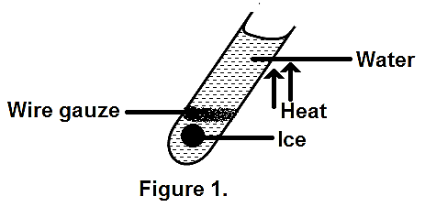

Which of the following is true about the experiment if Figure 1?

A. Ice takes long to melt because of the wire gauze.

B. Ice melts shortly after heating starts

C. water is a poor conductor of heat

D. water is a good conductor of heat

5. What type of motion is shown by the ticker tape in Figure 2?

Figure 2.

A. uniform acceleration B. uniform velocity

C. uniform displacement D. non uniform acceleration

6. Which of the following actions will cause the leaf of a negatively charged gold leaf electroscope to fall?

i) Bring a positively charged body near the cap

ii) Bring a negatively charged body near the cap

iii) Connecting the cap to earth.

A. (i) and (ii) only B. (ii) and (iii) only

C. (i) and (iii) only D. (i), ii) and (iii)

7. A dull block surface feels hotter even though it’s at the same temperature as a shiny surface because it:

A. has more heat energy than shiny surface.

B. emits more heat than shiny surface.

C. reflects more heat than shiny surface

D. conducts heat more.

8. An object is dropped from a chopper and hits the ground after 4 seconds. At what height was it dropped?

A. 20m B. 40m C. 50m D. 80m

9. In an electric field, a neutral point is a point where;

A. electric field lines intersect

B. no electric force is experienced

C. maximum electric force is experienced

D. field lines start form

10. A vibrator produces waves which travel a distance of 30m in 2 seconds and the distance between two successive crests is 5cm. Calculate the frequency of the waves.

A. 350Hz B. 320Hz C. 300Hz D. 150Hz

11. The resistance of a metal in the form of a wire increases with;

A. decrease in length B. increase in temperature

C. decrease in temperature D. increase in cross sectional area

12. Figure 3 shows two equal forces acting on a bar of length L.

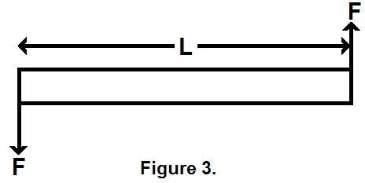

Which of the following statement(s) is/are true:

i) The resultant force on the bar is zero.

ii) The forces cause rotational effect

iii) The forces act in opposite directions.

A. i) only B. i) and ii) only

C. i), ii) and iii) D. ii) and iii) only

13. The capillarity rise in a tube is due to;

A. surface tension

B. high vapour pressure

C. adhesion being greater than cohesion force

D. cohesion force being greater than adhesion force

14. The sensitivity of a galvanometer can be increased by using;

A. smaller coil B. weaker magnet

C. weaker hair spring D. fewer turns of wire on the coil.

15. Figure 4 shows a coil and magnet. The e.m.f produced in the coil is due to;

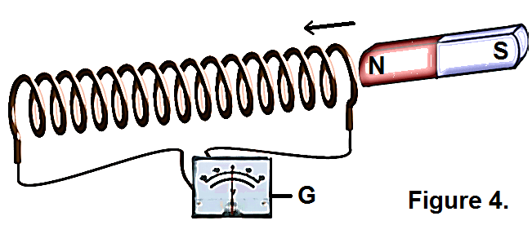

A. The attraction between the coil and magnet

B. the magnetic field outside the coil

C. the magnet placed close to the coil

D. the variation of magnetic field lines linking the coil

16. A possible isotopes of  has;

A. 2 protons and 3 neutrons B. 2 protons as 4 neutrons

C. 3 protons and 5 neutrons D. 4 protons and 3 neutrons

17. A real image as one which;

A. is inverted and magnified B. is erect and magnified

C. same size as the object D. can be formed on the screen

18. Figure 5 shows a simple barometer. What is the value of atmospheric pressure?

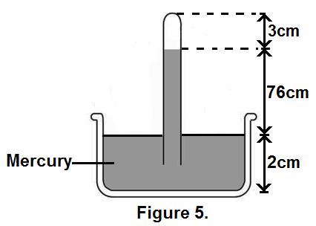

A. 76cmHg B. 74cmHg C. 78cmHg D. 79cmHg

19. The brightness on the screen of a TV set is determined by;

A. darkness in the room

B. the size of the screen

C. the number of electrons reaching the screen

D. the direction of the antenna.

20. Which of the following shows a pattern of a circular wave reflected from a convex reflector?

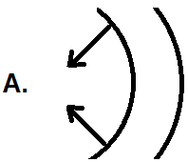 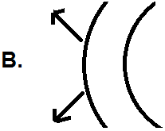 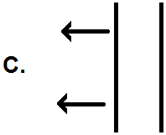 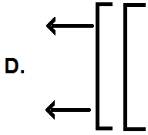

21. Loudness of a musical note depends on:

A. frequency B. amplitude

C. pitch D. velocity

22. Which of the following statements is true about gases?

A. the volume of a fixed mass of a gas increase as temperature

decreases.

B. the pressure of a fixed mass of a gas decreases as temperature increases

C. each molecule of a gas at a given temperature has a different speed.

D. the average kinetic energy of molecules of a gas depends on temperature.

23. A bullet of mass 0.02kg is fired with a speed of 40ms-1. Calculate its kinetic energy.

A. 0.4J B. 0.8J C. 16J D. 32J

24. Which of the following forms mechanical energy?

A. electrical energy and kinetic energy.

B. potential energy and nuclear energy

C. potential energy and kinetic energy

D. electrical energy and nuclear energy

25.

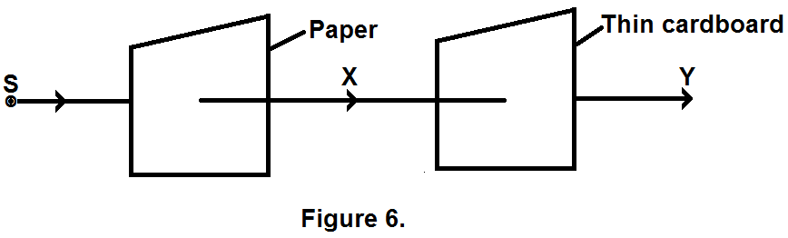

In Figure 6, S is source of radioactive particles **∝**, β and Ɣ. The beams at X and Y will contain;

X Y

A. **∝**, β, Ɣ β, Ɣ only

B. β, Ɣ only **∝** - only

C. β, Ɣ only Ɣ – only

D. **∝**, Ɣ only Ɣ – only

26.

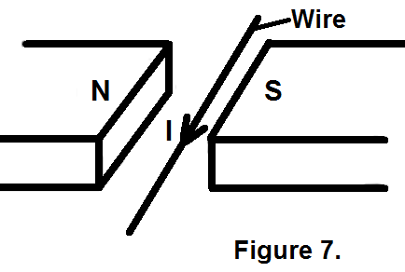

When a current Z flows through a wire placed in between poles of a U – shaped magnet shown in Figure 7, the wire will move.

A. upwards B. downwards

C. towards the South Pole D. towards the North Pole

27. The basic difference between transverse and longitudinal waves is in;

A. amplitude B. wavelength

C. direction of vibration D. medium through which the waves travel

28. A block of wood of volume 40cm3 floats in water with only half of its volume submerged. If the density of water is 1000kgm-3 determine the mass of the wood under water.

A. 0.5kg B. 0.02kg C. 0.005kg D. 0.002kg

29.

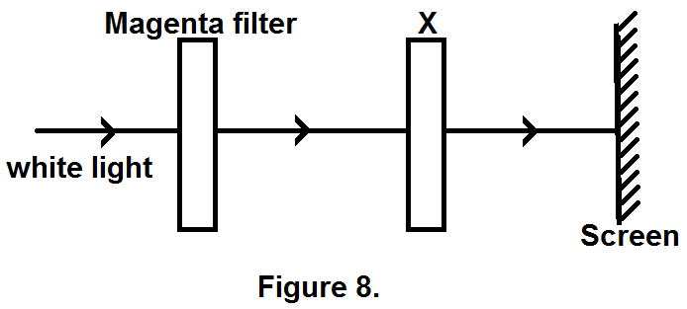

Figure 8. Shows white light incident on a magenta filter. What colour filter should X be so that red is seen on the screen?

A. cyan B. yellow C. black D. blue

30. An electric bulb has a resistance of 960Ω. Find the electrical power expended when connected to a 240V supply.

A.  B.  C.  D. 

31. Which of the following can be electrified by friction.

A. plastic pen B. wet wood

C. copper rod D. dry wood

32. A voltage of 440V is applied to the primary coil of a transformer of 200 turns.

If the voltage across the secondary is 11KV. What is the number of turns in the secondary coil?

A. 50 B. 80 C. 5.0 x 10**4** D. 8.0 x 10**4**

33. The hydraulic car brake system works on the principle of;

A. transmission of pressure in fluids

B. atmospheric pressure

C. distribution of force in a fluid.

D. high density of a fluid.

34. Local action in a simple cell is caused by the presence of:

A. zinc amalgam coating on zinc plate

B. manganese (IV) oxide around the copper plate.

C. hydrogen bubbles around the copper plate

D. impurities in zinc.

35. When a concave mirror is used as a shaving mirror, the image formed is:

A. magnified, virtual and erect B. magnified, real and erect

C. diminished, virtual and inverted D. diminished, real and erect

36. How much heat is needed to raise the temperature of 20g of water from 30**0**C to 60**0**C?

A. 2520J B. 6300J C. 12600J D. 84000J

37. A man standing 85m away from a tall wall fires a gun and hears the echo from the wall after 0.5s. Calculate the speed of sound in air.

A. 320ms**-1** B. 340ms**-1** C. 330ms**-1** D. 311ms**-1**

38. Element Emits radiation **r** and forms element Y as given in the equation.

  + r

What is radiation r?

A. alpha particle B. beta particle

C. gamma rays D. X – rays

39. Which of the following is not a primary source of energy?

A. water B. The sun C. wind D. dry cell

40. A body accelerates uniformly from rest and acquires a velocity of 60ms**-1** in half a minute. Find the distance covered by the body.

A. 15m B. 30m C. 900m D. 1800m

**SECTION B: (40 MARKS)**

41. a) Define a watt. (1 mark)

**……………………………………………………………………………………………..**

**……………………………………………………………………………………………..**

**……………………………………………………………………………………………..**

b) A boy of mass 45kg runs up a fight of 60steps. If each step is 12cm high, Find the work done against gravity by the boy. (2 marks)

**……………………………………………………………………………………………..**

**……………………………………………………………………………………………..**

**……………………………………………………………………………………………..**

**……………………………………………………………………………………………..**

42. a) What is a hard magnetic material? (1 mark)

**……………………………………………………………………………………………..**

**……………………………………………………………………………………………..**

**……………………………………………………………………………………………..**

b) State two ways in which a material can be demagnetized. (1 mark)

**……………………………………………………………………………………………..**

**……………………………………………………………………………………………..**

**……………………………………………………………………………………………..**

c) Sketch a field pattern between two conductor carrying current in the same direction. (2 marks)

43. a) Define the term heat capacity. (1 mark)

**……………………………………………………………………………………………..**

**……………………………………………………………………………………………..**

**……………………………………………………………………………………………..**

b) On a certain day when the temperature is 37**0**C, the pressure of gas in a gas jar is 740mmHg. Calculate the pressure of the gas when it’s cooled to a temperature of 17**0**C. (3 marks)

**……………………………………………………………………………………………..**

**……………………………………………………………………………………………..**

**……………………………………………………………………………………………..**

**……………………………………………………………………………………………..**

**……………………………………………………………………………………………..**

**……………………………………………………………………………………………..**

44. a) State the law of conservation of energy. (1 mark)

**……………………………………………………………………………………………..**

**……………………………………………………………………………………………..**

**……………………………………………………………………………………………..**

b) A body of mass 25kg falls freely from a height of 10m to the ground.

i) State the energy changes that take place. (1 mark)

**……………………………………………………………………………………………..**

**……………………………………………………………………………………………..**

**……………………………………………………………………………………………..**

ii) Calculate the velocity with which it hits the ground. (2 marks)

**……………………………………………………………………………………………..**

**……………………………………………………………………………………………..**

**……………………………………………………………………………………………..**

**……………………………………………………………………………………………..**

45. a) What is meant by the term electromotive force (e.m.f.)? (1 mark)

**……………………………………………………………………………………………..**

**……………………………………………………………………………………………..**

**……………………………………………………………………………………………..**

b) Figure 9 shows three resistors of 2Ω, 2Ω and 3Ω connected to source of e.m.f 20V and negligible internal resistance.

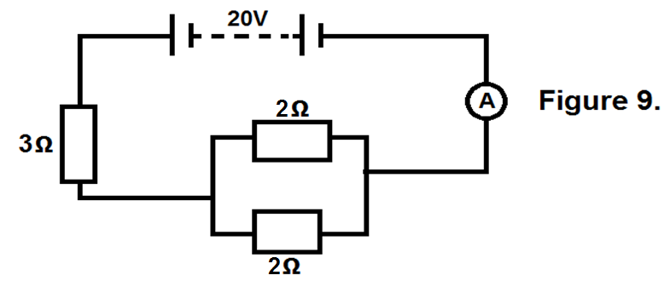

Calculate the current flowing in the circuit. (3 marks)

**……………………………………………………………………………………………..**

**……………………………………………………………………………………………..**

**……………………………………………………………………………………………..**

**……………………………………………………………………………………………..**

**……………………………………………………………………………………………..**

**……………………………………………………………………………………………..**

**……………………………………………………………………………………………..**

**……………………………………………………………………………………………..**

46. a) What is meant by the term total internal reflection? (1 mark)

**……………………………………………………………………………………………..**

**……………………………………………………………………………………………..**

**……………………………………………………………………………………………..**

b) A piece of glass material has critical angle of 18**0**. Calculate the refractive index of glass material. (2 marks)

**……………………………………………………………………………………………..**

**……………………………………………………………………………………………..**

**……………………………………………………………………………………………..**

**……………………………………………………………………………………………..**

c) State any two applications of total internal reflection. (1 mark)

**……………………………………………………………………………………………..**

**……………………………………………………………………………………………..**

**……………………………………………………………………………………………..**

47. a) Distinguish between mass and weight. (2 marks)

**……………………………………………………………………………………………..**

**……………………………………………………………………………………………..**

**……………………………………………………………………………………………..**

**……………………………………………………………………………………………..**

b) A body weighs 52N. It experiences an up thrust of 12N in a fluid. Find the apparent weight of the body in a fluid. (2 marks)

**……………………………………………………………………………………………..**

**……………………………………………………………………………………………..**

**……………………………………………………………………………………………..**

**……………………………………………………………………………………………..**

**……………………………………………………………………………………………..**

48. a) What is meant by the term half – life? (1 mark)

**……………………………………………………………………………………………..**

**……………………………………………………………………………………………..**

**……………………………………………………………………………………………..**

b) A radioactive sample takes 50 hours for 80% of its mass to decay. Find its half – life. (2 marks)

**……………………………………………………………………………………………..**

**……………………………………………………………………………………………..**

**……………………………………………………………………………………………..**

**……………………………………………………………………………………………..**

**……………………………………………………………………………………………..**

49. a) What is meant by the term reverberation? (1 mark)

**……………………………………………………………………………………………..**

**……………………………………………………………………………………………..**

**……………………………………………………………………………………………..**

b) State two factors that affect frequency of a vibrating string. (1 mark)

**……………………………………………………………………………………………..**

**……………………………………………………………………………………………..**

**……………………………………………………………………………………………. ……………………………………………………………………………………………..**

c) A sound wave of frequency 440Hz has a velocity of 330ms**-1**. Calculate the wave length. (2 marks)

**……………………………………………………………………………………………..**

**……………………………………………………………………………………………..**

**……………………………………………………………………………………………..**

**……………………………………………………………………………………………..**

**……………………………………………………………………………………………..**

50. a) Explain what happens when two insulators are rubbed together. (3 marks)

**……………………………………………………………………………………………..**

**……………………………………………………………………………………………..**

**……………………………………………………………………………………………..**

**……………………………………………………………………………………………..**

**……………………………………………………………………………………………..**

b) State two uses of a gold leaf electroscope. (2 marks)

**……………………………………………………………………………………………..**

**……………………………………………………………………………………………..**

**……………………………………………………………………………………………..**

**……………………………………………………………………………………………..**

**END**

..